**SOCKET.IO SESSION LINKED TO EXPRESS SESSION**

REF: <https://www.youtube.com/watch?v=uvsMiGZaing>

IN ORDER TO ACHIEVE THIS, WE HAVE TO DO NEXT:

1. MAKE SURE YOU HAVE INSTALLED REDIS, EXPRESS-SESSION AND CONNECT-REDIS NPM PACKAGES ALREADY.

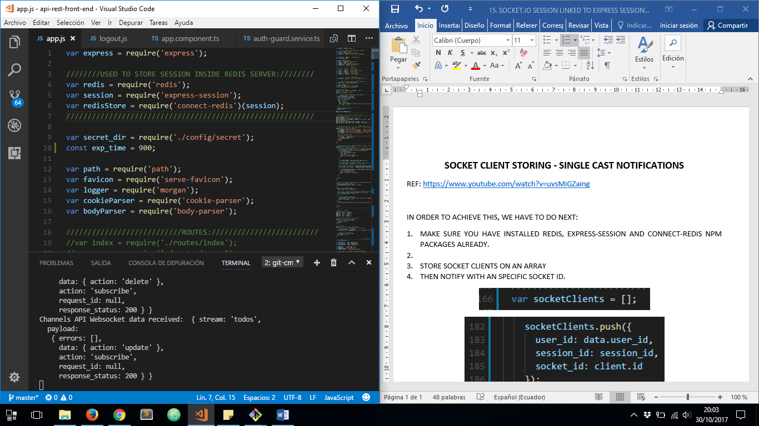

1. A NEW REDIS CLIENT MUST BE INSTANCED

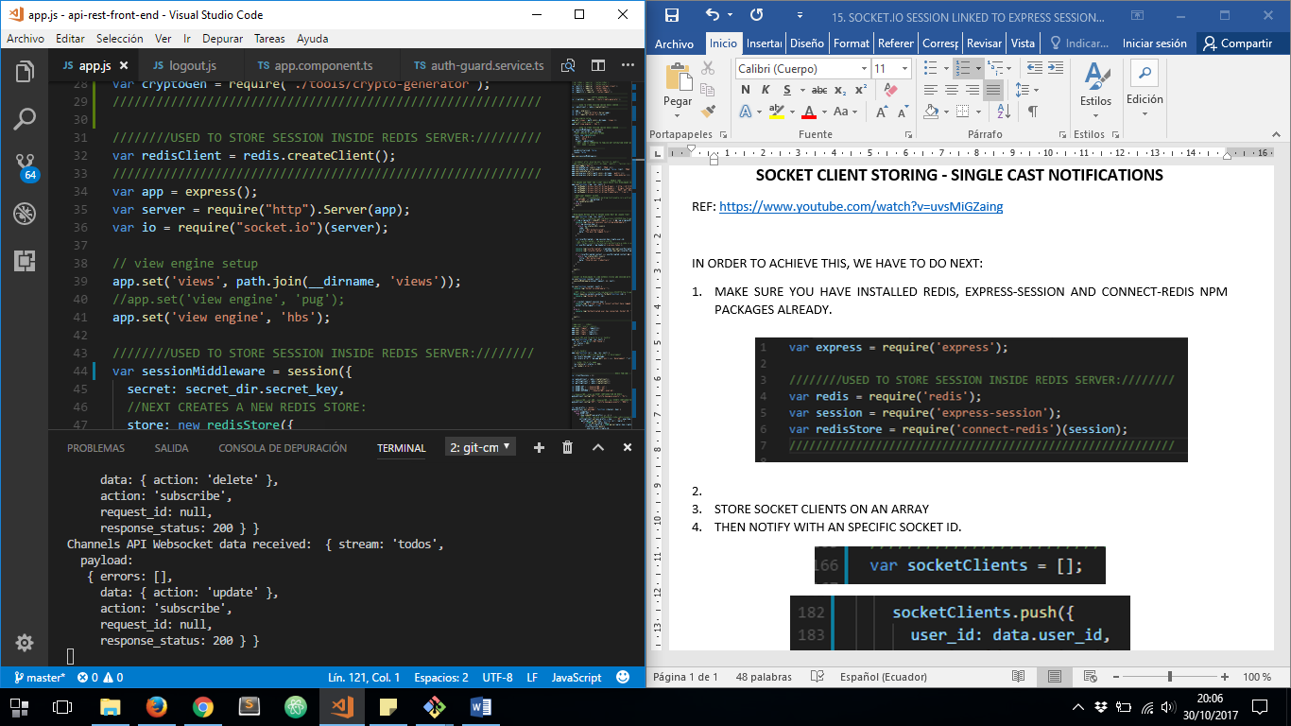

1. DECLARE A NEW EXPRESS – REDIS SESSION STORE ARRAY AND USE IT ON EXPRESS MIDDLEWARE

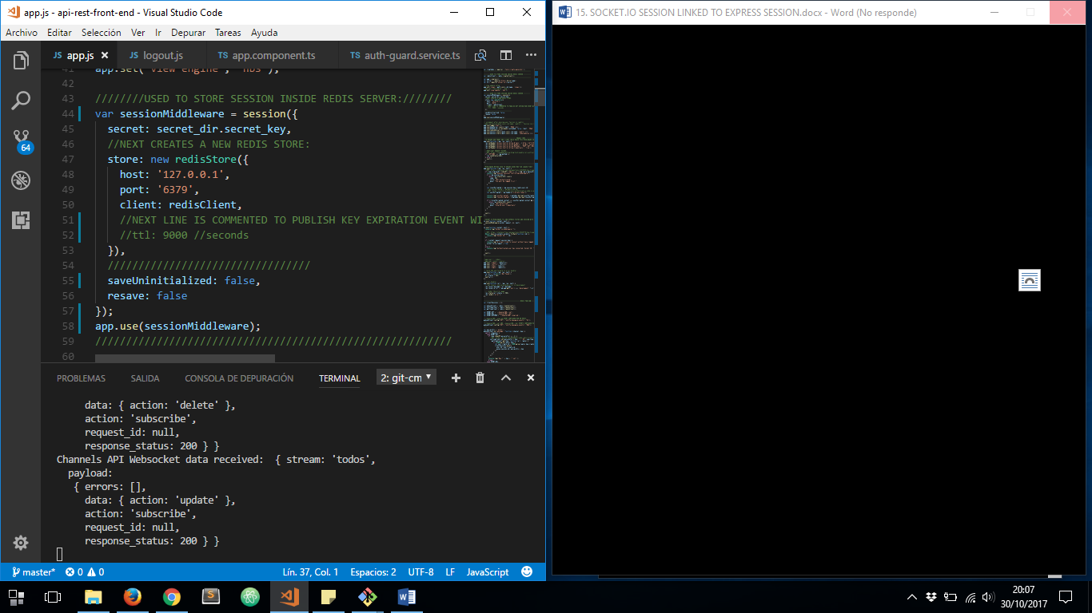

1. AND AFTER YOU HAVE DECLARED A NEW SOCKET.IO SERVER INSTANCE, YOU HAVE TO USE EXPRESS SESSION STORE CONFIGURATION ON SOCKET.IO MIDDLEWARE:

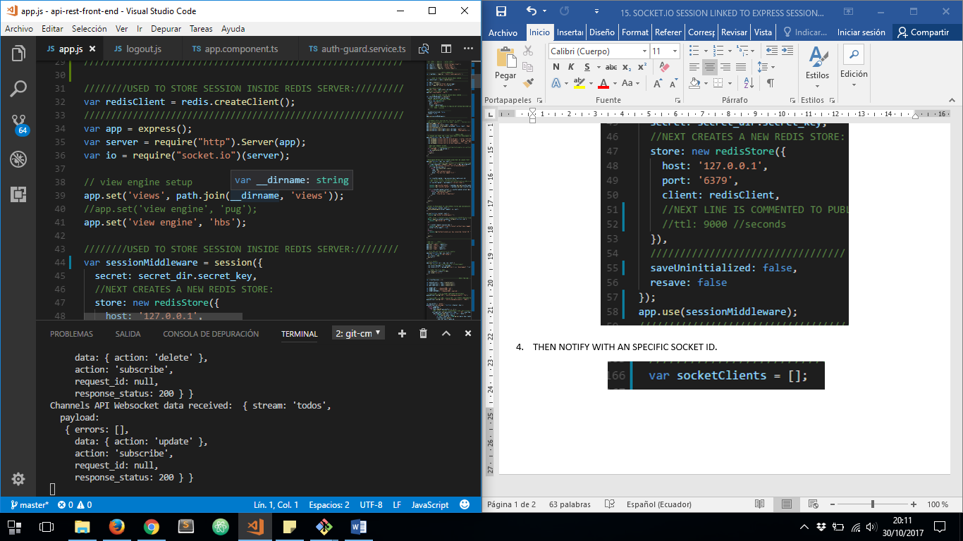

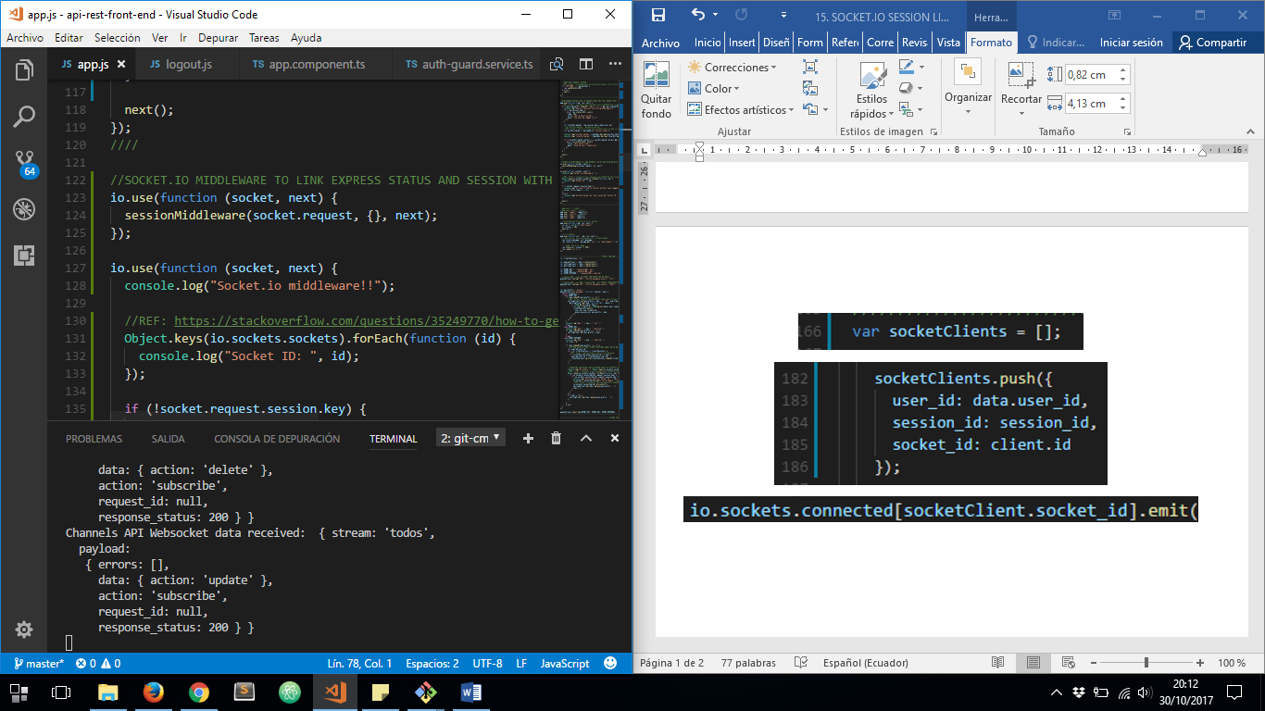

NOW WHEN A USER MAKES LOGIN, AFTER WE STORE A NEW SESSION KEY, WE WILL ABLE TO USE IT FROM SOCKET MIDDLEWARE TOO:

